UNITED STATES
SECURITIES AND EXCHANGE COMMISSION
Washington, D.C. 20549

SCHEDULE 14A
Proxy Statement Pursuant to Section 14(a) of
the Securities Exchange Act of 1934 (Amendment No. )

Filed by the Registrant x

Filed by a Party other than the Registrant ¨

Check the appropriate box:

¨ | Preliminary Proxy Statement
¨ | Confidential, for Use of the Commission Only (as permitted by Rule 14a-6(e)(2))
¨ | Definitive Proxy Statement
x | Definitive Additional Materials
¨ | Soliciting Material under §240.14a-12

Dollar General Corporation
(Name of Registrant as Specified in Its Charter)

(Name of Person(s) Filing Proxy Statement, if other than the Registrant)

Payment of Filing Fee (Check all boxes that apply):

x | No fee required
¨ | Fee paid previously with preliminary materials
¨ | Fee computed on table in exhibit required by Item 25(b) per Exchange Act Rules 14a-6(i)(1) and 0-11

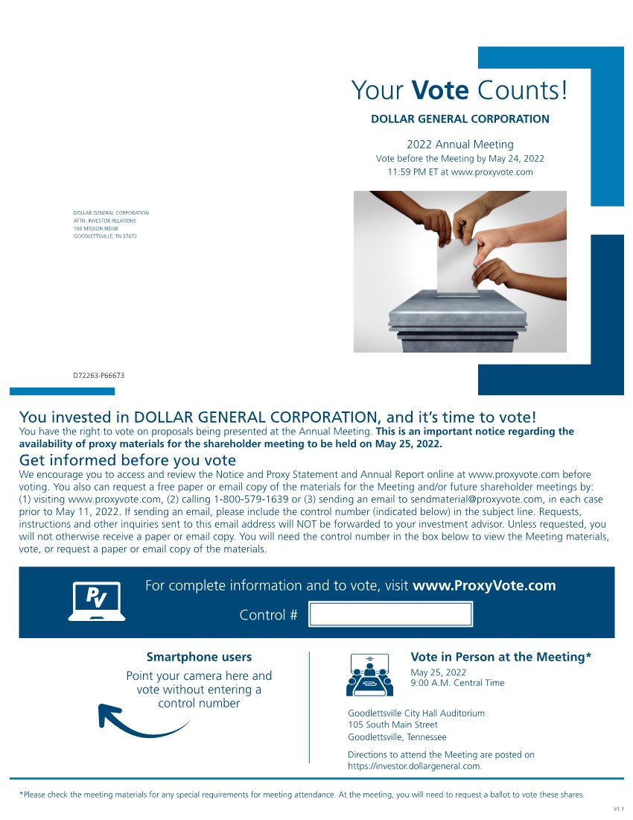 | Your Vote Counts! DOLLAR GENERAL CORPORATION ATTN: INVESTOR RELATIONS 100 MISSION RIDGE GOODLETTSVILLE, TN 37072 DOLLAR GENERAL CORPORATION 2022 Annual Meeting Vote before the Meeting by May 24, 2022 11:59 PM ET at www.proxyvote.com Vote in Person at the Meeting* May 25, 2022 9:00 A.M. Central Time Goodlettsville City Hall Auditorium 105 South Main Street Goodlettsville, Tennessee Directions to attend the Meeting are posted on https://investor.dollargeneral.com. *Please check the meeting materials for any special requirements for meeting attendance. At the meeting, you will need to request a ballot to vote these shares. Smartphone users Point your camera here and vote without entering a control number V1.1 For complete information and to vote, visit www.ProxyVote.com Control # D72263-P66673 Get informed before you vote We encourage you to access and review the Notice and Proxy Statement and Annual Report online at www.proxyvote.com before voting. You also can request a free paper or email copy of the materials for the Meeting and/or future shareholder meetings by: (1) visiting www.proxyvote.com, (2) calling 1-800-579-1639 or (3) sending an email to sendmaterial@proxyvote.com, in each case prior to May 11, 2022. If sending an email, please include the control number (indicated below) in the subject line. Requests, instructions and other inquiries sent to this email address will NOT be forwarded to your investment advisor. Unless requested, you will not otherwise receive a paper or email copy. You will need the control number in the box below to view the Meeting materials, vote, or request a paper or email copy of the materials. You invested in DOLLAR GENERAL CORPORATION, and it’s time to vote! You have the right to vote on proposals being presented at the Annual Meeting. This is an important notice regarding the availability of proxy materials for the shareholder meeting to be held on May 25, 2022.

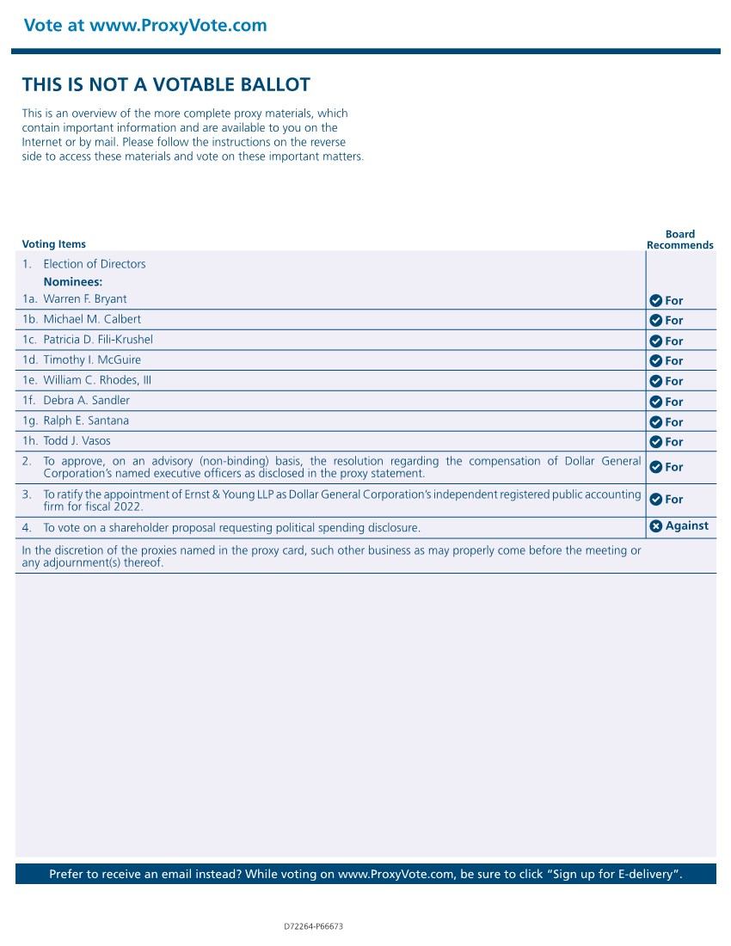 | Vote at www.ProxyVote.com Prefer to receive an email instead? While voting on www.ProxyVote.com, be sure to click “Sign up for E-delivery”. Voting Items Board Recommends D72264-P66673 THIS IS NOT A VOTABLE BALLOT This is an overview of the more complete proxy materials, which contain important information and are available to you on the Internet or by mail. Please follow the instructions on the reverse side to access these materials and vote on these important matters. 1. Election of Directors Nominees: 1c. Patricia D. Fili-Krushel 1a. Warren F. Bryant 1d. Timothy I. McGuire 1b. Michael M. Calbert 1e. William C. Rhodes, III 1f. Debra A. Sandler 1g. Ralph E. Santana 1h. Todd J. Vasos 2. To approve, on an advisory (non-binding) basis, the resolution regarding the compensation of Dollar General Corporation’s named executive officers as disclosed in the proxy statement. 3. To ratify the appointment of Ernst & Young LLP as Dollar General Corporation’s independent registered public accounting firm for fiscal 2022. 4. To vote on a shareholder proposal requesting political spending disclosure. For For For For For For For For For For In the discretion of the proxies named in the proxy card, such other business as may properly come before the meeting or any adjournment(s) thereof. Against

